JIRA Assignment

All issues screenshot of KSRTC and Online admission form

Online admission defect_01

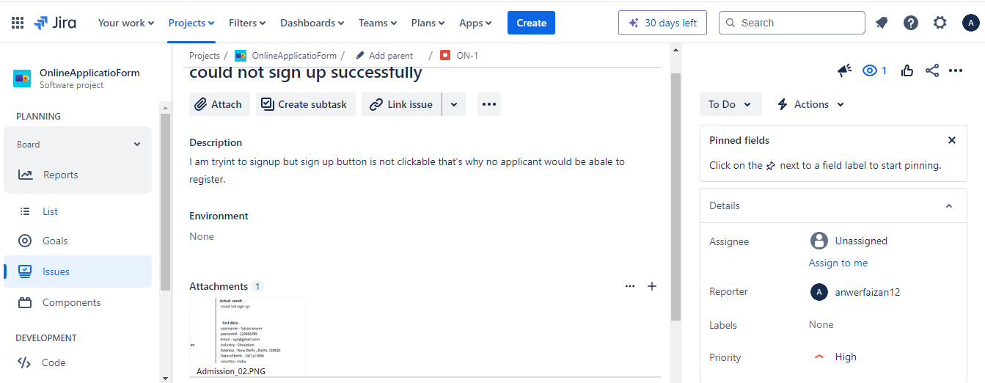

Online admission defect_02

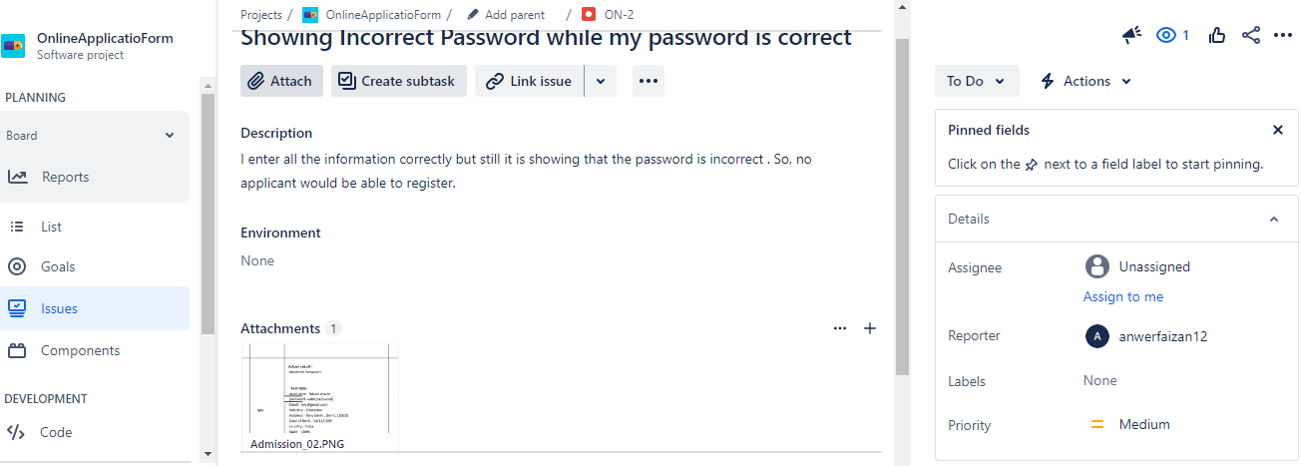

Online admission defect_03

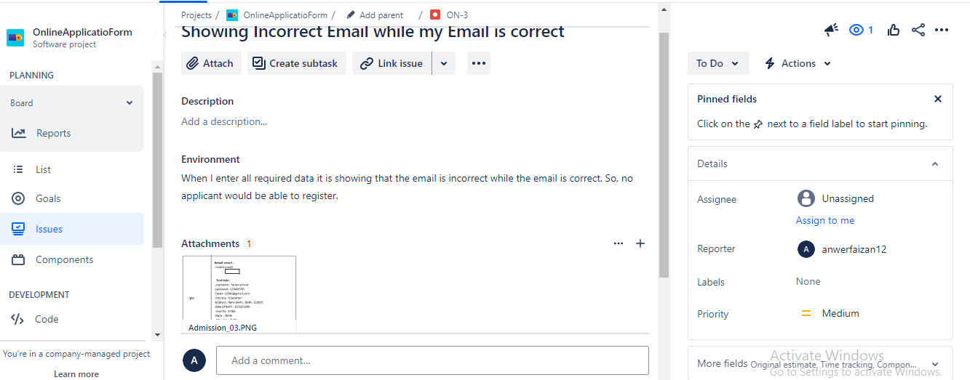

KSRTC defect_01

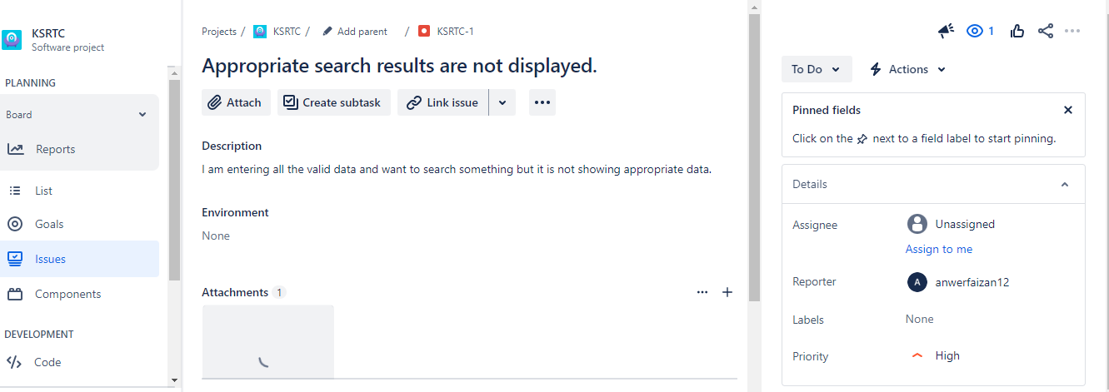

KSRTC defect_02

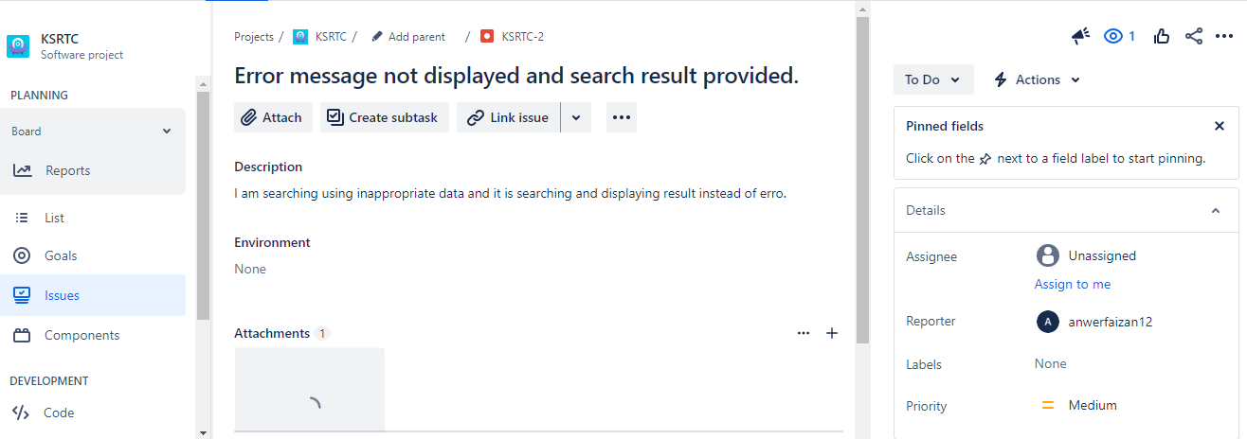

KSRTC defect_03

